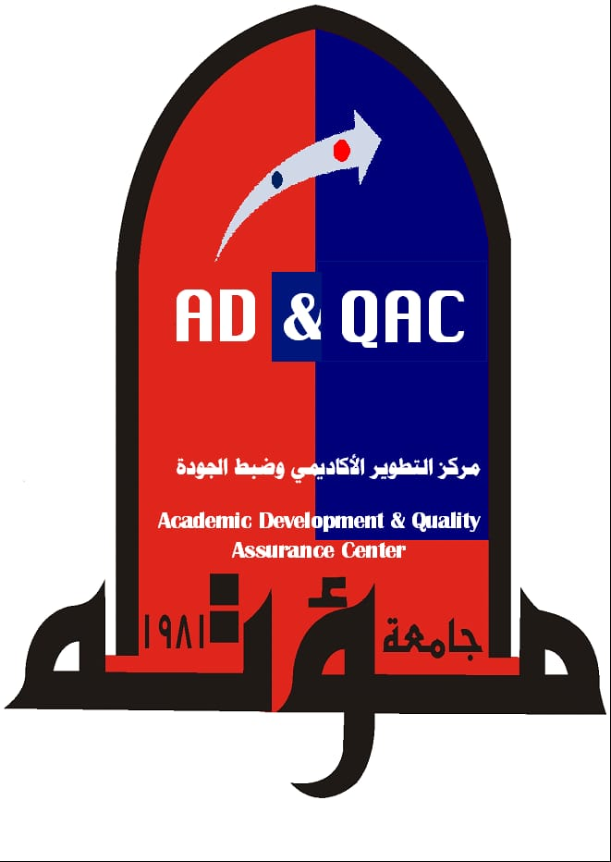 | Mutah University  Detailed Syllabus Form


First : Course Information:

- Course Number: |  | - Course Title: Medical Ethics
- Credit Hours: one hour |  | - College: Faculty of Medicine
- Pre-requisite |  | - Department:
- Instructor: |  | - Semester & Academic Year: 2nd year
- phone number:0797708262 |  | - E-mail: dr.nadrakandeel@mutah.edu.eg
- Office Hours: |  | - the time of the lecture: one hour
- Foor Num: | - Building Name: |  | - Office Num:
- Virtual office hours on Microsoft Teams: one hour

Second : General Course Description

1-Medical Ethics History
2- Dr-patient relationship 3- Consent 4- Confidentiality
5- Ethics of research 6- legal aspects of reproductive techniques
7- ethics of organ transplantation 8- Malpractice 9- Euthanasia 10- culture 11- Dignity 12- certificates and reports
Third : Course Objectives

1- Guide students about respecting their profession, colleagues and patients &
their role towards community.
2- How to write medical certificates and reports.
3- Protecting physicians and public from illegal or disgraceful conduct in medical practice or research.

Fourth: Expected Learning Outcomes

- ...............................................................................................................................الإرتقاء بمستوي طالب الطب ليلم بدوره في حماية المجتمع والمريض واحترام المهنه والأساتذه والزملاء والحفاظ علي سرية المهنه والمشاركه في تنمية البيئه والمجتمع ورفع الوعي وكفاءته المهنيه واحترام أخلاقيات البحث العلمي والإلمام بالمخالفات القنونيه والتي تضر بالمريض والقيم وقد تؤدي إلي إتهامه بالإهمال وتجنب الأخطاء الطبيه
- ....................................................................................................................................
- ....................................................................................................................................
Fifth : Course Plan Distribution & Learning Resources

Learning Resources | Topics to be Covered | Week  No.
Online lectures interactive Microsoft teams | 1-Medical Ethics History  2- Dr-patient relationship
Word notes | Consent - Confidentiality
Presentation data show slides | Ethics of research
 | legal aspects of reproductive techniques
 | ethics of organ transplantation
 | Euthanasia - culture
 | Dignity
 | certificates and reports
 | Malpractice

Sixth : Teaching Strategies and Methods

Teaching Strategies and Methods | No
Online lectures interactive Microsoft teams | 1
Discussion | 2
Exam | 3
 | 4
 | 5

Seventh : Methods of Assessment

Proportion of Final Evaluation | Evaluation Methods of | Week & Date | No.
Exam 40% med | Exam by E- learning 2 |  | 1.
Exam 60% final |  |  | 2.
 | Med 40 degree |  | 3.
 |  |  | 4.
 |  |  | 5
 | Final 60 degree |  | 6
(100%) | 100 degrees | Total

Eighth : Required Textbooks

- Primary Textbook:

1- Text book of MEDICAL ETHICS Erich H Loewy, M.D
- 2- Medical Law and Ethics 5th ed. Shaun D Pattinson.
- ....................................................................................................................................
- ....................................................................................................................................

- Secondary References
- ....................................................................................................................................
- ....................................................................................................................................
- ....................................................................................................................................
Ninth : General Instructions

Additional Notes, Office hours, Incomplete Exams, Reports, Papers, …etc | No
Medical ethics syllabus has advanced clinical information exceeding capability of 2nd year medical student  If there’s chance to postpone teaching Medical ethics to clinical years to achieve its goals | 1
 | 2
 | 3
 | 4
 | 5

